CCNA 4 Practice Final v5.0 Exam Answers 2015 (100%)

- Which three items are normally included when a log message is generated by a syslog client and forwarded to a syslog server? (Choose three.)

  - date and time of message
  - ID of sending device
  - length of message
  - message ID
  - checksum field
  - community ID

- Which WAN technology uses a fixed payload of 48 bytes and is transported across both switched and permanent virtual circuits?

  - ATM
  - ISDN
  - Frame Relay
  - metro Ethernet

- What can cause a reduction in available bandwidth on a cable broadband connection?

  - smaller cells
  - number of subscribers
  - committed information rate
  - distance from the central office of the provider

- A technician has been asked to configure a broadband connection for a teleworker. The technician has been instructed that all uploads and downloads for the connection must use existing phone lines. Which broadband technology should be used?

  - cable
  - DSL
  - ISDN
  - POTS

- Which three algorithms can be used to encrypt user data in an IPSec VPN framework? (Choose three.)

  - 3DES
  - AES
  - Diffie-Hellman
  - DES
  - ESP
  - SHA

- Which two Layer 1 requirements are outlined in the Data-over-Cable Service Interface Specification (DOCSIS)? (Choose two.)

  - channel widths
  - access method
  - maximum data rate
  - modulation techniques
  - compression techniques

- What makes the Cisco EasyVPN application a useful tool for VPN implementation?

  - It provides encryption algorithms unavailable in other systems.
  - It ensures that remote workers actually use the VPN for connectivity.
  - It simplifies the configuration tasks for the device that is used as the VPN server.
  - It allows a greater variety of network devices to be used for VPN connections.

- How many addresses will be available for dynamic NAT translation when a router is configured with the following commands?

Router(config)#ip nat pool TAME 209.165.201.23 209.165.201.30 netmask 255.255.255.224
Router(config)#ip nat inside source list 9 pool TAME

  - 7
  - 8
  - 9
  - 10
  - 24
  - 31

- Which three statements are true regarding the Frame Relay LMI? (Choose three.)

  - The LMI provides a virtual circuit (VC) status mechanism.
  - The LMI type must always be manually configured.
  - The available LMI types are CHAP and PAP.
  - The LMI types supported by Cisco routers are CISCO and IETF.
  - The LMI type configured on the router must match the one used on the Frame Relay switch.
  - The LMI uses reserved DLCIs to exchange messages between the DTE and DCE.

- The output of the show ip interface brief command indicates that Serial0 is up but the line protocol is down. What are two possible causes for the line protocol being in the down state? (Choose two.)

  - The clock rate is not set on the DTE.
  - An incorrect default gateway is set on the router.
  - A network is missing from the routing protocol configuration.
  - The encapsulation on the Serial0 interface is incorrect.
  - Keepalives are not being sent by the remote device.

- A user is unable to connect to the Internet. The network administrator decides to use the top-down troubleshooting approach. Which action should the administrator perform first?

  - Run the tracert command to identify the faulty device.
  - Check the patch cable connection from the PC to the wall.
  - Enter an IP address in the address bar of the web browser to determine if DNS has failed.
  - Run the ipconfig command to verify the IP address, subnet mask, and gateway on the PC.

- How does an SNMP trap aid network monitoring and management?

  - It reports to the management station by responding to polls.
  - It collects information for the management station by using polling devices.
  - It sends an alert message to the management station when a threshold is reached.
  - It flags attempts to begin a DoS attack on the network.

- What are two characteristics of DSL technology? (Choose two.)

  - Uploads typically offer larger transfer rates than downloads.
  - Service providers deploy DSL in the local loop of the telephone network.
  - DSL download rates are reduced by large volumes of POTS voice traffic.
  - Filters and splitters allow POTS and DSL traffic to share the same medium.
  - DSL is a shared medium that allows many users to share bandwidth available from the DSLAM.

- A network administrator has moved the company intranet web server from a switch port to a dedicated router interface. How can the administrator determine how this change has affected performance and availability on the company intranet?

  - Conduct a performance test and compare with the baseline that was established previously.
  - Determine performance on the intranet by monitoring load times of company web pages from remote sites.
  - Interview departmental administrative assistants and determine if they think load time for web pages has improved.
  - Compare the hit counts on the company web server for the current week to the values that were recorded in previous weeks.

- Which statement is true about NCP?

  - Link termination is the responsibility of NCP.
  - Each network protocol has a corresponding NCP.
  - NCP establishes the initial link between PPP devices.
  - NCP tests the link to ensure that the link quality is sufficient.

- Which two statements about NetFlow are true? (Choose two.)

  - NetFlow can be used to create baseline documentation.
  - NetFlow can be used to collect performance indicators such as interface errors, CPU usage, and memory usage.
  - NetFlow can be used to monitor traffic statistics, including packet payload content.
  - NetFlow is a Cisco-specific feature that enables the collection of detailed traffic profiles.
  - NetFlow is a network monitoring and event reporting tool.
  - NetFlow traffic collectors use a “pull” based model to acquire traffic statistics from ports of interest.

- What are three parameters that are used by NetFlow to classify traffic? (Choose three.)

  - ingress interface
  - TOS field
  - egress interface
  - number of packets
  - number of bytes
  - port number

- What is the purpose of the Cisco Enterprise Architecture?

  - It replaces the three-layer hierarchical model with a flat network approach.
  - It provides an enterprise-wide system network architecture that helps protect, optimize, and grow the network infrastructure that supports the business processes of a company.
  - It provides services and functionality to the core layer by grouping various components into a single component that is located in the access layer.
  - It reduces overall network traffic by grouping server farms, the management server, corporate intranet, and e-commerce routers in the same layer.

- Refer to the exhibit. While planning an upgrade, a network administrator uses the Cisco NetFlow utility to analyze data flow in the current network. What generated the most packets?

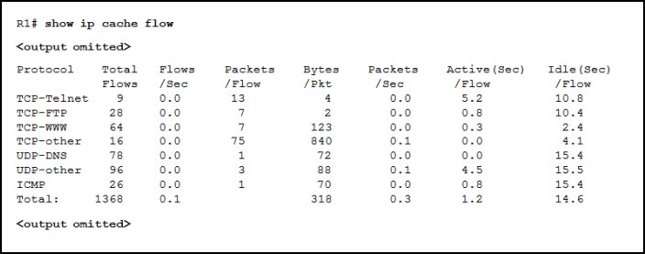

  - ICMP
  - TCP-Telnet
  - TCP-other
  - UDP-DNS
  - UDP-other

- Which is a clientless VPN solution for mobile workers?

  - GRE
  - IPsec
  - SSH
  - SSL

- What is IPsec?

  - a specification for the way in which a group of protocols and algorithms combine to create VPNs
  - a protocol that is used to create a VPN at Layer 2 of the OSI model
  - a 56-bit authentication and encryption method that must be used to create VPN tunnels
  - a means by which routers and VPN gateways read and forward packets with encrypted packet headers

- What are two significant benefits that are provided by IPsec? (Choose two.)

  - authentication
  - encryption
  - automatic creation of a public network
  - automatic creation of a private network
  - encapsulation

- How does STDM allocate bandwidth on a serial connection?

  - It statically assigns bandwidth based upon pre-assigned time slots.
  - It ensures each of the time slices are assigned to individual conversations.
  - It keeps track of conversations that require extra bandwidth. It then dynamically reassigns unused time slices on an as-needed basis.
  - It ensures that bandwidth is allocated to each channel or time slot regardless of whether the station using the channel has data to

- Which statement is true about the operation of a site-to-site VPN connection?

  - The data is encrypted and decrypted by the sending and target hosts.
  - The data is encrypted and decrypted by VPN gateways at both the sending and receiving sides.
  - The data is encrypted by the sending host and decrypted by the VPN gateway at the receiving side.
  - The data is encrypted by the VPN gateway at the sending side and decrypted by the target host.

- Which two products are part of the Cisco Collaboration Architecture? (Choose two.)

  - Cisco Borderless End Point​
  - Cisco TelePresence​
  - Cisco Unified Communications
  - Cisco Unified Computing
  - Cisco Virtual Private Network

- A company has been assigned the 203.0.113.0/27 block of IP addresses by the ISP. The company has over 6000 internal devices. What type of NAT would be most appropriate for the employee workstations of the company?
  - static NAT
  - dynamic NAT
  - port forwarding
  - PAT off the external router interface
  - dynamic NAT overload using the pool of addresses

- An administrator needs to configure a router so that internal network servers are accessible from the Internet. Each server is configured with a private IPv4 address. What type of NAT should the administrator configure?

  - PAT
  - dynamic NAT
  - static NAT
  - NAT overloading

- Refer to the exhibit. Based on the configuration of R1, which device is the inside host and what is the inside local address of this host?

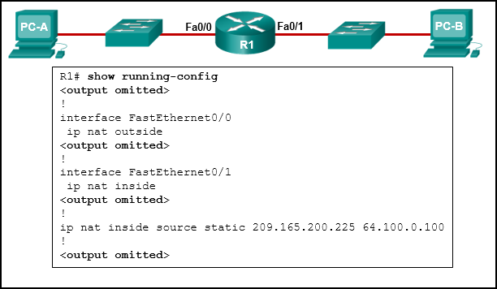

  - PC-A with address 64.100.0.100
  - PC-A with address 209.165.200.225
  - PC-B with address 64.100.0.100
  - PC-B with address 209.165.200.225
- Refer to the exhibit. A PC at address 10.1.1.45 is unable to access the Internet. What is the most likely cause of the problem?

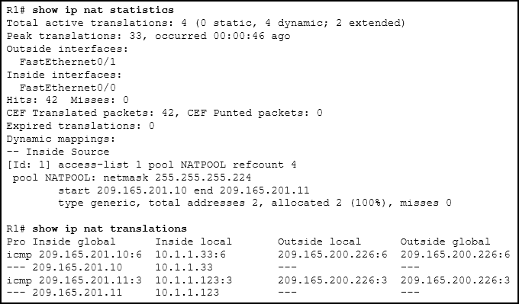

  - The NAT pool has been exhausted.
  - The wrong netmask was used on the NAT pool.
  - Access-list 1 has not been configured properly.
  - The inside and outside interfaces have been configured backwards.

- Which three parts of a Frame Relay Layer 2 PDU are used for congestion control? (Choose three.)

  - the 10-bit DLCI
  - the Extended Address field
  - the C/R bit
  - the FECN bit
  - the BECN bit
  - the DE bit

- Refer to the exhibit. A network administrator has configured router Edge_Router as shown in the output. Connectivity is failing between Edge_Router and a non-Cisco router running Frame Relay. What should be done to repair this Layer 2 connectivity?

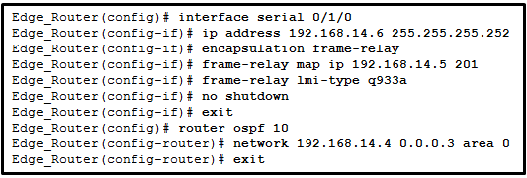

  - Issue the ietf keyword when enabling Frame Relay on interface serial 0/1/0.
  - Issue the broadcast keyword when performing static mapping on interface serial 0/1/0.
  - Correct the IP address used in the frame-relay map command.
  - Issue the frame-relay lmi-type ansi command on interface serial 0/1/0.
  - Modify the OSPF process-id from 10 to 1.

- What is the relationship between the DE and the CIR in Frame Relay?

  - When the CIR is exceeded, an Inverse ARP DE message notifies the source to reduce frame transmission speed.
  - The DE bit will indicate when the CIR committed burst size should be applied.
  - When the CIR on a given DLCI is exceeded, the DE bit of frames above the CIR is set.
  - The XON/XOFF flow control mechanism sets the DE bit when the CIR is exceeded.

- Which IEEE standard defines the WiMax technology?

  - 802.3
  - 802.5
  - 802.11
  - 802.16

- For a VPN, which technology provides secure remote access over broadband?

  - QoS
  - ADSL
  - LTE
  - Ipsec

- Which two technologies are implemented by organizations to support teleworker remote connections? (Choose two.)

  - CMTS
  - CDMA
  - DOCSIS
  - VPN
  - Ipsec

- Which basic network module of the Enterprise Architecture is the fundamental component of a campus design?

  - data center
  - services module
  - access-distribution
  - enterprise edge

- What are two examples of network problems that are found at the data link layer? (Choose two.)

  - encapsulation errors
  - framing errors
  - electromagnetic interference
  - incorrect interface clock rates
  - late collisions and jabber

- Users are reporting longer delays in authentication and in accessing network resources during certain time periods of the week. What kind of information should network engineers check to find out if this situation is part of a normal network behavior?

  - syslog records and messages
  - the network performance baseline
  - debug output and packet captures
  - network configuration files

- Refer to the exhibit. Which three events will occur as a result of the configuration shown on R1? (Choose three.)

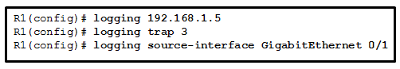

  - Messages that are sent to the syslog server will be limited to levels 3 or lower.
  - Messages that are sent to the syslog server will be limited to levels 3 and higher.
  - Only traffic that originates from the GigabitEthernet 0/1 interface will be monitored.
  - Messages that are sent to the syslog server will use 192.168.1.5 as the destination IP address.
  - The syslog messages will contain the IP address the GigabitEthernet 0/1 interface.
  - For multiple occurrences of the same error, only the first three messages will be sent to the server.

- What is a disadvantage of a packet-switched network compared to a circuit-switched network?

  - higher cost
  - fixed capacity
  - less flexibility
  - higher latency

- What is a type of VPN that is generally transparent to the end user?

  - site-to-site
  - remote access
  - public
  - private

- Which statement best describes a WAN?

  - A WAN interconnects LANs over long distances.
  - A WAN is a public utility that enables access to the Internet.
  - WAN is another name for the Internet.
  - A WAN is a LAN that is extended to provide secure remote network access.

- How many 64 kb/s voice channels are combined to produce a T1 line?

  - 8
  - 16
  - 24
  - 32

- In the Cisco Enterprise Architectures network design approach what is the purpose of the enterprise edge module?

  - to provide access to IP telephony services, wireless controller services, and unified services
  - to provide high-speed connectivity and protection for servers
  - to forward traffic from one local network to another
  - to provide Internet, VPN, and WAN connections
- Refer to the exhibit. A ping from R1 to 10.1.1.2 is successful, but a ping from R1 to any address in the 192.168.2.0 network fails. What is the cause of this problem?

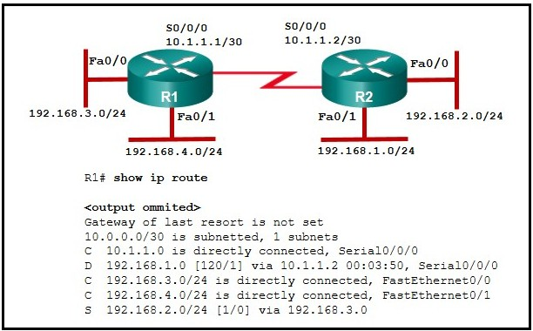

  - There is no gateway of last resort at R1.
  - The serial interface between the two routers is down.
  - A default route is not configured on R1.
  - The static route for 192.168.2.0 is incorrectly configured.

- Refer to the exhibit. A small office uses an ISR to provide connectivity for both wired and wireless computers. One day, a sales person who is using a laptop cannot connect to Server1 through the wireless network. A network technician attempts to determine if the problem is on the wireless or the wired network. The technician pings successfully from the wireless laptop to the default gateway IP address on the ISR. What should be the next troubleshooting step?

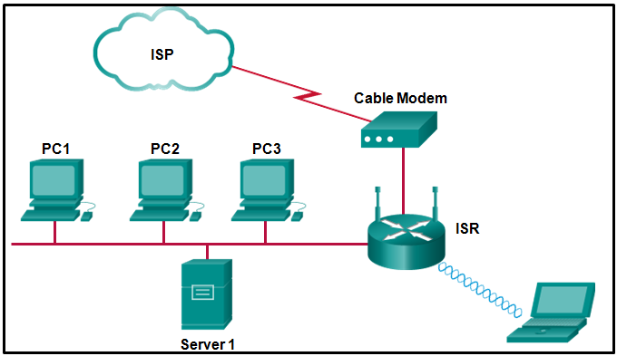

  - Ping from the laptop to PC1.
  - Ping from Server1 to PC1.
  - Ping from Server1 to its gateway IP address.
  - Ping from the laptop to the Ethernet port on the cable modem.

- Refer to the exhibit. A network administrator is troubleshooting the OSPF network. The 10.10.0.0/16 network is not showing up in the routing table of Router1. What is the probable cause of this problem

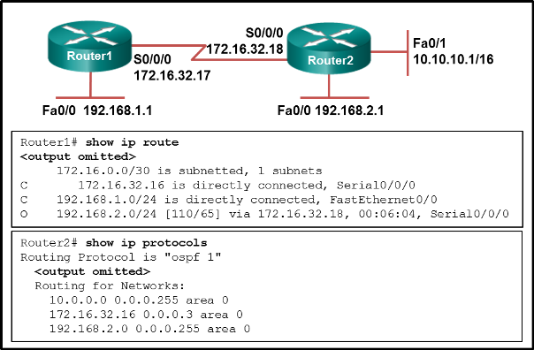

  - The serial interface on Router2 is down.
  - The OSPF process is not running on Router2.
  - The OSPF process is configured incorrectly on Router1.
  - There is an incorrect wildcard mask statement for network 10.10.0.0/16 on Router2.

- Refer to the exhibit. R3 has the following configuration:

R3# show running-config
–some output text omitted–
interface serial0
bandwidth 128
ip address 192.168.11.2 255.255.255.0
encapsulation frame-relay
frame-relay map ip 192.168.11.2 30 broadcast

After the command R3# debug frame-relay packet is executed, a ping is issued from R3 to R1 but is unsuccessful. Based on the output of the debug command shown in the graphic and the router configuration, what is the problem?

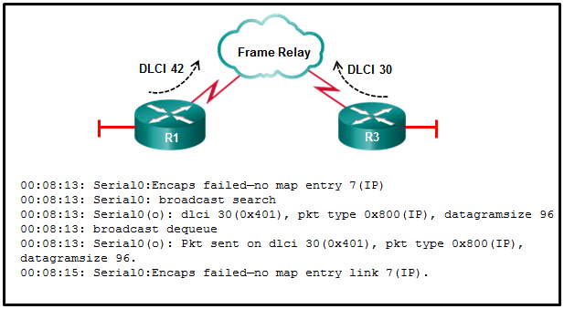

  - No clock rate has been configured on interface s0.
  - There is an incorrect DLCI number in the map statement.
  - An incorrect IP address exists in the map statement.
  - The encapsulation frame-relay command is missing the broadcast keyword.

- Refer to the exhibit. What type of Layer 2 encapsulation will be used for connection D on the basis of this configuration on a newly installed router:

RtrA(config)# interface serial0/0/0
RtrA(config-if)# ip address 128.107.0.2 255.255.255.252
RtrA(config-if)# no shutdown

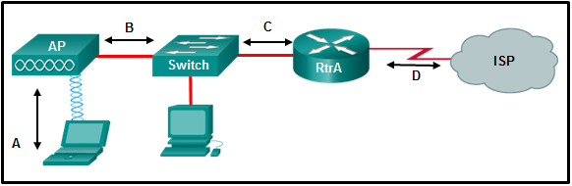

  - Ethernet
  - Frame Relay
  - HDLC
  - PPP

- The security policy in a company specifies that the staff in the sales department must use a VPN to connect to the corporate network to access the sales data when they travel to meet customers. What component is needed by the sales staff to establish a remote VPN connection?

  - VPN gateway
  - VPN appliance
  - VPN concentrator
  - VPN client software

- Which PPP protocol allows a device to specify an IP address for routing over the PPP link?

  - PAP
  - CHAP
  - LCP
  - IPCP

- Refer to the exhibit. A network administrator has configured routers RTA and RTB, but cannot ping from serial interface to serial interface. Which layer of the OSI model is the most likely cause of the problem?

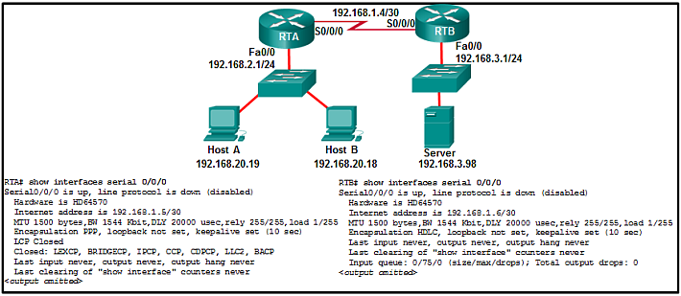

  - application
  - transport
  - network
  - data link
  - physical

- What is the default location for Cisco routers and switches to send critical logging events?
  - auxiliary port
  - console port
  - syslog server
  - virtual terminal

- Open the PT Activity. Perform the tasks in the activity instructions and then answer the question.

Which message is displayed on the web browser?

  - Well done!
  - PPP is working!
  - PPP configured!
  - Configured correctly!

- Open the PT activity. Perform the tasks in the activity instructions and then answer the question.

What is the IP address or range of IP addresses that are used as the inside global address for packets that originate from PC1 and are going to the server?​

  - 209.165.200.231
  - 209.165.200.225 – 200.165.200.229
  - 209.165.200.231 – 209.165.200.239
  - 192.168.10.21
  - 192.168.10.1 – 192.168.10.254

